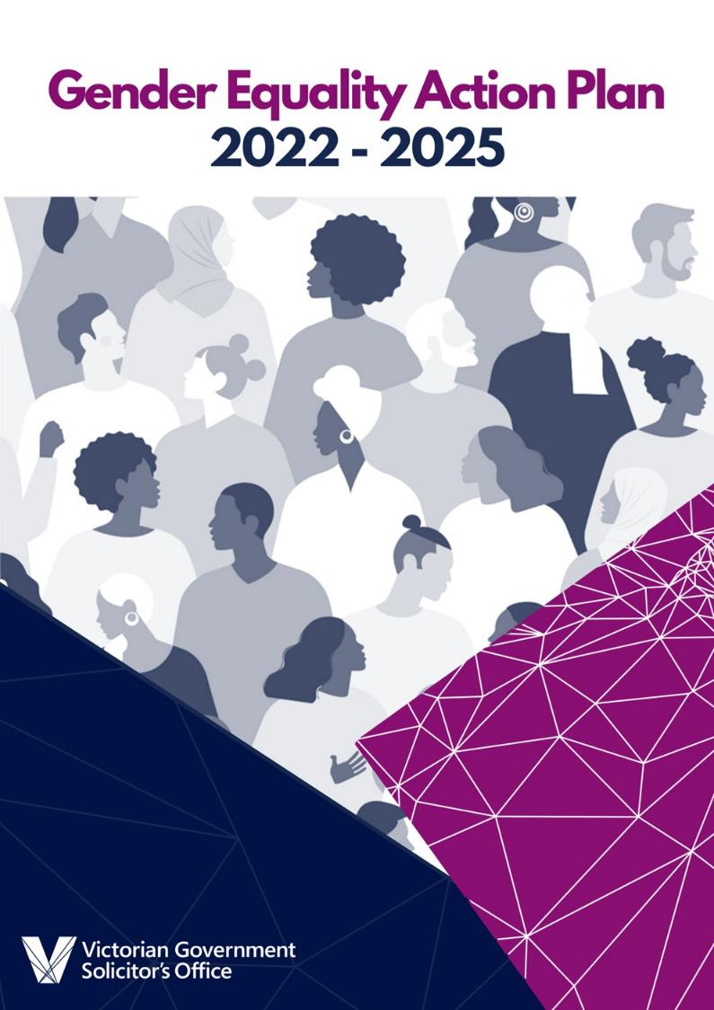

**Contents**

A message from the Victorian Government Solicitor 3

Our collective commitment 4

About VGSO 5

Introduction 7

About VGSO's Gender Equality Action Plan (GEAP) 7

Developing the Gender Equality Action Plan 9

Baseline audit results and analysis 9

Meaningful consultation and engagement 9

The case for change 10

From ideas to action 15

Focus Area 1: Building awareness and capability 15

Focus Area 2: Fostering gender diverse culture 16

Focus Area 3: Data and technology enhancement 17

Focus Area 4: Career growth and recruitment opportunities 18

Implementation and next steps 19

Implementation framework 19

Measuring progress 20

Appendix: VGSO's Gender Equality Audit Results 21

**Acknowledgement of Country**

|  |  |
| --- | --- |
| C:\Users\twh\AppData\Local\Microsoft\Windows\INetCache\Content.MSO\3D48889B.tmp | The Victorian Government Solicitor's Office (VGSO) acknowledges the Traditional Owners of the land, the Wurundjeri and Boonwurrung peoples, and we pay our respects to their Elders - past, present and emerging - and the Aboriginal Elders of other communities.  In this document 'Aboriginal' refers to both Aboriginal and Torres Strait Islander people. |
| C:\Users\twh\AppData\Local\Microsoft\Windows\INetCache\Content.MSO\4617533D.tmp |

# **A message from the Victorian Government Solicitor**

I am pleased to share with you VGSO's 2022-2025 Gender Equality Action Plan (**GEAP**). This GEAP has been endorsed by our Executive Leadership Team (ELT) and reflects actions we will take as an organisation to implement and measure change in order to achieve workplace gender equality.

I am proud that VGSO is a diverse and vibrant workforce, with an already strong commitment to acknowledging and celebrating diversity. I welcome the opportunity to further enhance our work in this space, particularly in the area of gender diversity and equality.

In 2017, VGSO formally established a Diversity and Inclusion (**D&I**) Committee. Members of this Committee, with strong support from our ELT, and in conjunction with our People and Culture team, have played a critical role in ensuring VGSO is a diverse and inclusive place to work.

While we have strong foundations in place, the preparation of our GEAP has provided valuable opportunity to reflect on and consider ways to further enhance our commitment to building and nurturing a diverse and inclusive workplace culture. Our GEAP is a product of listening to and consulting with our people, understanding their experiences, and identifying what will make a genuine difference to their workplace experiences.

Our GEAP defines strategies and measures for promoting gender equality at VGSO within four key focus areas. Through consultation and engagement we've identified where we can improve, the capability required to do this, and the culture we ultimately need to enable the sustainable and meaningful change we're committed to. We acknowledge that advancing gender equality is a shared responsibility for all at VGSO to commit to and participate in.

Our focus areas include:

* Building awareness and capability
* Fostering gender diverse culture
* Data and technology enhancements
* Career growth and recruitment opportunities

Our GEAP demonstrates our commitment to ensuring equitable access to opportunities, responsibilities, resources and outcomes for all employees. A gender diverse workforce will realise:

* Improved efficiency and productivity
* Innovation and creativity as a result of diverse perspectives
* Improved access and retention of talent due to an inclusive culture
* Positive workplace culture where diversity of thought is valued

In a broader sense, VGSO acknowledges gender equality as a human right, a precondition for the prevention of family violence and other forms of violence against women and girls and essential for an economically prosperous, safe and healthy society.

I, along with VGSO's ELT, fully endorse the actions within our GEAP and recognise the significant opportunities identified to further embed a gender equitable workplace culture at VGSO.



**Matthew Hocking,**Victorian Government Solicitor

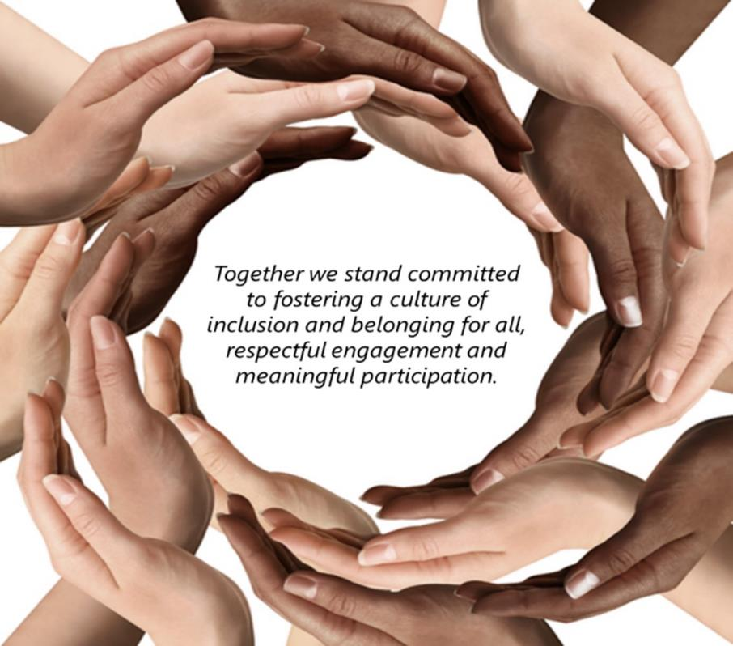

# **Our collective commitment**

# **About VGSO**

VGSO provides responsive legal services exclusively for the Victorian Government and public sector. Our place within government ensures we are at the centre of legal change, reform and problem-solving. We operate as a service-driven legal professional practice and strive for excellence in this competitive environment. In all aspects of our operations, we aim to role model and live by our values: Responsiveness, Integrity, Insight, Collaboration and Excellence.

We know that organisations that embrace diversity and inclusion experience higher levels of engagement and creativity in the workplace. VGSO currently employs 320 individuals that bring their unique strengths, perspectives and personal attributes to create a rich and vibrant culture. We value individuality and encourage collaboration and creativity - bringing together diverse ways of thinking into how we work, make decisions and deliver value for our clients.

As an organisation - we pride ourselves in being a workplace that encourages flexibility to assist our employees to balance work and non-work commitments. 77% of our employees and 78% of our ELT comprise of women (as at 30 June 2021). Our leaders are visible and lead by example to drive a compassionate, caring and inclusive culture.

**Our commitment to diversity and inclusion at VGSO**

VGSO's Diversity and Inclusion (D&I) Committee was established in 2017 to provide representation for different perspectives and meaningful participation towards shaping our culture. Since its inception, the D&I Committee have championed a range of diversity initiatives across the organisation, geared towards promoting an inclusive culture for all.

Our D&I Committee includes enthusiastic individuals, keen to progress VGSO's D&I agenda and make a genuine difference to the experiences of our people. VGSO is also a member of the

Diversity Council Australia (DCA), a peak body leading D&I in the workplace, with access to best practices, exciting events and valuable resources to inform future D&I initiatives.

|  |
| --- |
| The D&I Committee has six distinct strands:   * **Gender**- seeks to advocate for gender equality and diversity across VGSO and to promote positive cultural change at an organisation level. * **Disability**- aims to remove physical, attitudinal, communication and social barriers to ensure the full inclusion and participation of people with disability. * **First Nations Safety & Inclusion**- promotes cultural awareness and respect for Aboriginal and Torres Strait Island peoples and culture among all staff. * **LGBTIQ**- supports people to express their sexual orientation and gender identity without inhibitions. * **Age**- actively works to overcome stereotypes about younger and older workers, fostering inclusion, connection and empowerment. * **Multicultural**- promotes cultural diversity and inclusion to enhance awareness and support for people from diverse cultures and backgrounds.   Each of these strands are led by employees who represent a cross-section across VGSO. |



**How committed is the VGSO in supporting workplace gender equality at an organisational level?**

**4.28**

**(average rating**

**out of 5)**



***"VGSO values diversity and inclusion. As a member of our Diversity and Inclusion Committee, I appreciate the opportunities available to be involved in initiatives and action to promote and celebrate different forms of diversity in the workplace. During the consultation process of preparing the GEAP, we've been able to reflect on additional ways VGSO can build and nurture a diverse and inclusive workplace culture. I look forward to contributing to the execution of strategies and measures defined for promoting gender equality at the VGSO. I am specifically interested in furthering our understanding of how gender intersects with other factors such as sexual orientation, age or ethnicity and await the opportunity to take action to address any data gaps that exist to ensure valuable insights in this area can be obtained and acted upon."***

- D&I Committee member

# **Introduction**

## About VGSO's Gender Equality Action Plan (GEAP)

VGSO's **GEAP sets out a progressive framework for action** for driving sustainable systemic and behavioural change to achieve gender equality across our organisation. The GEAP is underpinned by the **Gender Equality Act 2020[1]** (the Act) which strives to improve workplace gender equality in the Victorian Public Sector, universities and local councils. The Act commenced on 31 March 2021 and promotes gender equality by:

1. Requiring the Victorian Public Sector, local councils and universities to take positive action towards achieving workplace gender equality.
2. Requiring these organisations to consider and promote gender equality in their policies, programs and services.
3. Establishing the Public Sector Gender Equality Commissioner to provide education, support implementation and enforce compliance.

VGSO's GEAP provides a unique opportunity to build on current initiatives towards fostering a diverse and inclusive workplace for all our employees. It recognises and builds on the **guiding principles of gender equality** as espoused in the Act:

* All Victorians should live in a safe and equal society, have access to equal power, resources and opportunities and be treated with dignity, respect and fairness.
* Gender equality benefits all Victorians regardless of gender
* Gender equality is a human right and precondition to social justice
* Gender equality brings significant economic, social and health benefits for Victoria
* Gender equality is a precondition for the prevention of family violence and other forms of violence against women and girls
* Advancing gender equality is a shared responsibility across the Victorian community
* All human beings, regardless of gender, should be free to develop their personal abilities, pursue their professional careers and make choices about their lives without being limited by gender stereotypes, gender roles or prejudices
* Gender inequality may be compounded by other forms of disadvantage or discrimination that a person may experience on the basis of Aboriginality, age, disability, ethnicity, gender identity, race, religion, sexual orientation and other attributes
* Women have historically experienced discrimination and disadvantage on the basis of sex and gender
* Special measures may be necessary to achieve gender equality.

VGSO's GEAP was **co-designed with our employees**, generating a deeper understanding of the experiences of our employees and the potential barriers to realising the gender equality principles at VGSO. The resultant action plan outlines targeted strategies spanning across our workplace systems, capability and culture that will enable us to implement meaningful change.

Definitions and key concepts

**Gender**

Gender refers to the characteristics of women, men, girls and boys that are socially constructed. This includes norms, behaviours and roles associated with being a woman, man, girl or boy, as well as relationships with each other. As a social construct, gender varies from society to society and can change over time.[2] Gender interacts with but is different from sex, which refers to the different biological and physiological characteristics of females, males and intersex persons, such as chromosomes, hormones and reproductive organs. Gender and sex are related to but different from gender identity. Gender identity refers to a person’s deeply felt, internal and individual experience of gender, which may or may not correspond to the person’s physiology or designated sex at birth.

***"The VGSO is committed to fostering an inclusive culture across all genders, ensuring everyone is treated with respect and equality. We also pride ourselves in having a strong representation of women in our leadership teams. As a member of the Executive Leadership Team, I recognise that everyone has unique requirements and lifestyles and support our people to pursue their desired career opportunities by way of secondments, facilitating career breaks to attend to growing families and offering flexibility of work as much as practicable."***

- Executive Leadership Team Member

**Gender Equality**

Gender equality is when people of all genders have equal rights, responsibilities and opportunities. Everyone is affected by gender inequality - women, men, trans and gender diverse people, children and families. It impacts people of all ages and backgrounds.[3]

**Intersectionality**

‘Intersectionality’ (also known as intersectional disadvantage or discrimination) refers to the ways in which different aspects of a person’s identity can expose them to overlapping forms of discrimination and marginalisation.[4] Gender inequality may be compounded by other forms of disadvantage or discrimination that a person my experience due to other characteristics, such as:

* Race
* Aboriginality
* Religion
* Ethnicity
* Disability
* Age
* Sexual orientation
* Gender identity

Intersectionality recognises that the causes of disadvantage or discrimination do not exist independently, but intersect and overlap with gender inequality, magnifying the severity and frequency of the impacts while also raising barriers to support.[5]

# **Developing the Gender Equality Action Plan**

## Baseline audit results and analysis

The development of VGSO's GEAP commenced with a **comprehensive baseline audit** to understand our current state through a **range of organisational indicators**, as outlined by the Act. These include:

1. Gender composition at all levels of the workforce
2. Gender composition of governing bodies
3. Gender pay equity
4. Workplace sexual harassment
5. Recruitment and promotion
6. Leave and flexibility
7. Gendered work segregation

The key insights from VGSO's Gender Equality Audit include:

* Women make up the majority of VGSO's workforce at all levels from junior roles to Executive and across all employment categories and age groups
* The majority of the workforce are employed on an ongoing full-time basis, with 20% of the workforce on a flexible work arrangement, the majority whom are women. 43% of our People Leaders work part time
* The overall median Gender Pay Gap as at June 2021 was 2% favouring men
* There were no formal sexual harassment complaints in 2020/2021 Financial Year, however 3 people in the 2021 People Matter Survey indicated experiences of sexual harassment in the workplace, of which all were women
* The uptake of workplace flexible working arrangements was a key theme in the audit data. There was clear uptake of flexible work arrangements by women, in comparison to men which includes the use of parental leave. We have observed a slight increase in men accessing parental leave.
* The recruitment data during this reporting cycle shows that 63% of people recruited to VGSO were women. More men were recruited at the VPS Grade 6, suggesting a positive shift towards gender balance.

Due to current systems and reporting limitations we were unable to fully report on intersectionality data formally but have overlayed, where possible, the People Matter Survey demographic data as a starting point to discuss intersectionality during the consultation period. We have also identified improving our ability to collect and report on such data in our strategy and measures to enable us to apply a deeper intersectionality lens to gender equality in the future.

A comprehensive look at VGSO's Gender Equality Audit results can be found in the Appendix. These results formed the basis for our next stage of engaging in meaningful consultation with leaders and employees across the organisation.

## Meaningful consultation and engagement

Meaningful consultation and engagement across all levels of the organisation and the Community and Public Sector Union (CPSU) is essential to adopting a co-design approach for the GEAP. Our consultation and engagement process adopted multiple communication channels and opportunities for constructive feedback, debate and inputs through two rounds of consultation:

|  |
| --- |
| **Round 1: Sharing baseline audit analysis and results** - this round was focused on sharing the baseline audit results with different audiences and enabling them to reflect on the relevant insights and implications from the data. This included:   * ***Presentations and liaisons with***:   + The Executive Leadership Team (ELT as VGSO governing body)   + The D&I Committee   + The CPSU * ***Office-wide drop-in sessions*** (3 sessions attended by over 130 employees) * ***Setting up a dedicated GEAP mailbox*** to enable employees a clear avenue for raising follow-up questions, issues or suggestions on enhancing gender equality at VGSO * ***Creating a dedicated Gender Equality intranet page***, providing easy access information about the Gender Equality Act 2020, key links and resources, along with the timeline for activities and upcoming consultation opportunities in Round 2. This page also housed a summary of VGSO's audit results and a recording of office-wide drop-in sessions to allow employees who may have missed out on attending to have an opportunity to engage with and understand the results.   **Round 2: Identifying the key areas of focus for the GEAP** - this round was focused on understanding the lived experience amongst our employees and seeking their feedback and suggestions to inform the actions, strategies and measures included in the GEAP. This round included two key consultation opportunities:   * ***Anonymous survey*** - Employees had the opportunity to provide their feedback and input by way of an anonymous survey managed by VGSO's People and Culture (P&C) team. The survey sought to seek priority focus areas from employees, along with their suggested strategies to action them. 52 employees participated in the survey, providing a rich source of qualitative feedback and commentary. * ***Action Focus Groups*** - The action focus groups built on the key priorities identified through the survey and explored employee experiences and barriers across these themes. To ensure autonomy and independence in the process and promote psychological safety amongst participants to share their views, VGSO partnered with an external provider to facilitate 3 action focus groups. A summary of discussions was then provided to VGSO to inform the development of the GEAP strategies. The action focus groups were attended by 28 employees which represented a good cross-section across the organisation. |

## The case for change

***"I feel like VGSO has a proactive approach to gender equality but is an environment that seeks ongoing learning. I think it would be great to have a deeper understanding of the issues in this space and hear from people that have lived this experience. Often we can't see what we don't understand. This would take the learning from the theory to real world. Not only does this educate our people but also create a more empathetic workforce.***

***It has been great to be involved in the consultation process and feel heard about how we move forward."***

- People Leader and focus group participant

VGSO's collective commitment espouses our long term vision for creating meaningful and sustainable shifts that go beyond just gender equality, towards achieving celebrating and embracing diversity in all its forms in everything we do.

***"Together we stand committed to fostering a culture of inclusion and belonging for all, respectful engagement and meaningful participation."***

VGSO has a **strong track record** for investing in and supporting initiatives that further the gender equality agenda.

**VGSO's gender equality related initiatives and achievements so far include:**

* Implemented an office-wide mandatory Respect in the Workplace program (People Leader and employee sessions) in 2016 with biannual refreshers run every two years.
* Established dedicated Equal Opportunity Contact Officers (EOCOs) adequately trained and upskilled since 2016, with periodic refresher training and regular recruitment drives to ensure coverage and a good representative cross-section of employees
* Established the D&I Committee in 2017 with clear strands of focus that have since accountability for driving and reporting on targeted initiatives
* Introduced the VPS All Roles Flex Policy in 2017 which has recently been updated to the Flexible Work Policy (2021) to further embed flexibility and hybrid work practices across the organisation
* Adopting a flexibility lens when scheduling events and training to enable greater participation and inclusion
* Participated actively in range of annual Career Fairs to attract a diverse group of applicants through the recruitment of seasonal clerks and law graduates
* Introduced Family Violence Leave Towards Common Practice (TCP) to all employees, creating awareness on available supports for family violence
* Developed and rolled out VGSO Family Violence Guidance document in 2020 to create awareness on family violence and offer support to employees and People Leaders
* Enabled all employees access to an online Family Violence training module in 2020 to create further awareness and understanding of family violence
* Developed an annual D&I Calendar of key diversity events and celebration days of significance such as International Women's Day, Harmony Day, International Day against Homophobia, Biphopia, Intersexism and Transphobia (IDAHOBIT), NAIDOC week and have regularly participated in the Pride march
* Improved accessibility of lifts for people with vision impairments at VGSO office locations
* Promotion of the use of gender pronouns in email signatures by the D&I Committee and implementation in 2021
* Hosted a 'Kids Conference' for VGSO parents to attend with their children virtually during school holidays in lockdown
* Introduced mandatory induction training modules for all new starters on "Respect in the Workplace" along with other compliance modules.

VGSO baseline audit results in conjunction with the key themes emerging from consultation and engagement activities sets out a clear case for building on our initiatives and achievements so far towards making tangible changes in the following areas:

* **Building awareness and capability**

***What we heard***

VGSO has a wide range of policies, procedures and supports to assist employees with issues relating to flexible work arrangements, parental leave entitlements, family violence as well as sexual harassment. However, the consultation process identified a gap in employee knowledge and awareness of these policies and procedures, where, when and how to access them and avenues for getting targeted supports. A strong training need was identified in the areas of diversity and inclusion, gender equality, family violence and intersectionality across the organisation at all levels. Low visibility and awareness could potentially be a barrier to employees embracing the benefits of these policies and supports fully to support their diverse needs (regardless of gender and personal circumstances).

***Our opportunity for change***

There is an opportunity for enhancing understanding and awareness through training for employees and People Leaders on intersectionality, family violence, flexible work arrangements, parental leave entitlements and sexual and gendered harassment. It also includes an emphasis on building capability across leaders and key support roles (EOCOs and Mental Health First Aiders [MHFAs]) to engage in supportive conversations with employees on these issues and directing them to appropriate resources and targeted supports.

* **Fostering a gender diverse culture**

***What we heard***

VGSO prides itself in having the right policies, training and guidance to ensure a diverse and inclusive culture for all. However, the consultation process identified a gap in how these resources are operationalised into day-to-day practice and brought to life through consistent application across all levels of the organisation. Inconsistencies in practices may create varying experiences for employees on the ground (e.g. perceived barriers in seeking flexible work arrangements where family or carer demands do not apply). This is essential for ensuring a genuine culture of flexibility, regardless of gender, caring responsibilities and personal circumstances.

***Our opportunity for change***

There is an opportunity fostering higher levels of trust and accountability in relation to inclusion and diversity across all levels of the organisation. This includes senior leaders leading by example, adopting a diversity and inclusion lens to making operational decisions and employees at all levels understanding and playing an active role in creating an inclusive culture that is underpinned by respect.

**77% of our employees and 78% of our ELT comprise of women**



* **Data and technology enhancements**

***What we heard***

Through the baseline audit process, VGSO was able to identify gaps in our data collection methods and ability to segment key organisational indicators by intersectionality data. More robust intersectionality data collection mechanism can help inform a more nuanced understanding of the organisational indicators and their implications. The consultation process also identified the need to improve on the existing knowledge management systems (such as the intranet) to promote visibility of and access to relevant information and resources. Better systems will enable greater transparency and insights to drive future initiatives.

***Our opportunity for change***

There is an opportunity to enhance reporting mechanisms and data collection methods on intersectionality and tracking metrics for specific diversity parameters to further gender equality at organisational level. This also includes systemic improvements to ensure timely and easy access to policies and supports through longer term improvements to VGSO's intranet (Collaborate), its knowledge management and search capacity.

* **Career growth and recruitment opportunities**

***What we heard***

The consultation process identified the need for providing greater visibility to career progression opportunities (secondments in particular). The feedback also highlighted the need to attract a greater diversity of applicants to VGSO by showcasing the range of benefits that can be availed by all employees, regardless of gender, age, cultural background, disability, etc., challenging perceptions around traditional gendered roles. This could also be promoted more effectively across current employees to deliver a stronger employee value proposition and VGSO's brand as an employer.

***Our opportunity for change***

There is an opportunity to provide greater transparency in the selection and decision making processes involved in taking on secondments with clients. This is likely to encourage more targeted conversations to open more opportunities for stepping up through the Performance and Development Plan (PDP). We also have an opportunity to enhance talent attraction through an intersectionality lens by promoting the entitlements that can availed by any employees, regardless of gender (e.g. generous leave provisions for secondary carers). Establishing strategic partnerships with targeted community organisations may also allow us to expand our recruitment pool, attracting candidates who bring a rich diversity of experiences and personal attributes with them.

Based on the consultation rounds, feedback mechanisms established for all employees, and available data, we did not have sufficient feedback or insights on intersectionality to inform specific actions to mitigate the compounding of disadvantage as a result of intersectionality. We also noted that a number of survey respondents for the anonymous survey through the consultation process, chose not to disclose relevant demographic data, suggesting limited understanding of how such data may be utilised.

As a starting point, VGSO is committed to focus on consciously creating opportunities to gather intersectionality data through different channels. We have also included an emphasis on upskilling employees and People Leaders on intersectionality through training to create more awareness. This has been captured as an action under Focus area 3: Data and technology enhancements.

VGSO's GEAP includes actions in relation to the gender pay gap which was identified in the Audit. However, this was not a key theme raised during consultation. We will continue to monitor closely from an internal process and policy perspective through regular reporting on the shifts in the gender pay gap with employee movements.



***"My experience with VGSO around gender equality (as a male secondary carer) and support/flexibility as a parent was extremely positive. I felt supported in my preference to take a longer period of parental leave following the birth of my daughter (through long service leave) and to return to work in a 0.6 job-sharing capacity for a 12 month period. I was grateful my preferences were valued and accommodated, particularly during a time where there were staff shortages and a pressure on the office to maximise utility. It was a credit to my managers at the lead counsel and AVGS level that the importance of flexible work in relation to a new parent was acknowledged and prioritised, particularly in relation to a secondary carer seeking to work reduced hours."***

- Solicitor and Team Leader

# **From ideas to action**

## Focus Area 1: Building awareness and capability

|  |  |  |  |  |
| --- | --- | --- | --- | --- |
| **Actions** | **Measures** | **Responsibility** | **Timeline** | **Indicator\*** |
| * Ensure a clear and consistent understanding of flexible work arrangements and processes, through multiple communication and engagement channels (Collaborate, Branch meetings, manager led discussions and training) * Review current policies and guidance materials on sexual harassment, family violence, occupational violence and aggression, clarifying risk prevention measures and reporting processes * Awareness training for employees and People Leaders** on understanding inclusive work practices, sexual harassment, family violence and related supports and provisions * Upskill People Leaders on understanding and leading meaningful discussions on relevant policies, processes and inclusive behaviours at an employee and team level * Upskill MHFAs and EOCOs to have more targeted supportive conversations with employees in relation to sexual harassment and family violence and connect them with relevant policies and supports * Periodic refresher training on key policies, processes and supports to highlight practical case studies and applications * Reinforce relevant policies and available options during key transitional stages in the employee lifecycle (recruitment, induction, parental leave transitions from and back to the workforce) | * Improvements in Workplace Flexibility and Equal Employment Opportunities metrics in the People Matter Survey * Clear communication and promotion of key policies and guidance * Training participation rates and feedback on increased awareness and confidence * Increase in page views for resource pages on Collaborate * Increase in uptake of formal and informal flexible work arrangements, regardless of carer/parental responsibilities * Increase in support outreach contacts (MHFAs and EOCOs) and access of specialised supports (specialist helplines via Employee Wellbeing Services) | * People and Culture * Other relevant Corporate Services functions * People Leaders | April 2022 to April 2024 | 4,5 & 6 |

*\*Linkages to Gender Equality Audit indicators **People Leaders include members of the ELT for the purposes of this plan*

## Focus Area 2: Fostering gender diverse culture

|  |  |  |  |  |
| --- | --- | --- | --- | --- |
| **Actions** | **Measures** | **Responsibility** | **Timeline** | **Indicator\*** |
| * Review policy statements, guidance and resources to reflect inclusive language, for all genders, intersectionality, secondary carers and employees with diverse personal circumstances (i.e. beyond carer and family responsibilities) * Reinforce a culture of care through senior leadership actions and role modelling of inclusive behaviours and flexibility in work practices * Senior leadership involvement and sponsorship for activities driven through the D&I Committee * People Leaders to use a diversity and inclusion lens in planning and making operational decisions * Build leadership accountability through upward feedback on leadership practices and behaviours * People Leaders to further embed consistent applications of policies and procedures at an individual level to ensure equity in experiences, regardless of gender and personal circumstances * Participate in and embrace the principles of the Respect in the Workplace training sessions * Build accountability for adopting respectful behaviours through feedback on behaviours outlined in the VGSO Capability Framework (VCF) | * Improvements in Workplace Flexibility and Equal Employment Opportunities cultural indicators in the People Matter Survey * Increase in senior leadership involvement and sponsorship for D&I activities * Improvements in Senior Leadership and Manager Support metrics in the People Matter Survey * Implement a 360 Feedback process for leaders * Increase in engagement and participation at all levels for D&I activities and events (incl. attendance, volunteering to organise and facilitating events and training) * Targeted feedback against the VCF through PDPs | * ELT * People Leaders * All employees * D&I Committee * People and Culture | April 2022 to April 2024 | 1,2,5 & 6 |

## Focus Area 3: Data and technology enhancement

|  |  |  |  |  |
| --- | --- | --- | --- | --- |
| **Actions** | **Measures** | **Responsibility** | **Timeline** | **Indicator\*** |
| * Address the gaps identified in the Gender Equality Audit data to capture intersectionality in order to include in regular analysis * Understand and improve the barriers to self-identification of intersectional data * Develop regular analysis and reporting processes for the Gender Equality Workforce Indicators * Closely monitor any fluctuations in the gender pay gap with the aim to reduce the gap * Provide regular data reports to ELT on diversity and inclusion to inform decision making * Improve Collaborate infrastructure, navigation and search functionality to enhance access to relevant policies, resources and supports | * Ability to easily and regularly access and report on gender workforce data * Intersectionality data is able to be captured and reported on regularly * Increase in response to People Matter Survey intersectional questions as a result of a high trust and inclusive culture * Regular reporting on the shifts in the gender pay gap with employee movements * Detailed reporting on progress of Gender Equality in the workplace | * People and Culture * Other relevant Corporate Services functions | April 2022 to April 2025 | 1,2,3,4&5 |

## Focus Area 4: Career growth and recruitment opportunities

|  |  |  |  |  |
| --- | --- | --- | --- | --- |
| **Actions** | **Measures** | **Responsibility** | **Timeline** | **Indicator\*** |
| * Clarify the process for secondments and acting positions to provide greater transparency * Employees and People Leaders to discuss and explore interest in secondment opportunities and stretch projects during PDP discussions * Increase visibility of employees on client secondments through the monthly P&C Updates * Promote benefits of flexibility, diversity and inclusion at VGSO in recruitment campaigns and through the interview process (what you can expect - our culture and environment) * Continue to review pay equity during recruitment and hiring decisions * Explore opportunities to attract more diversity in applicants by highlighting parental leave benefits for all (including secondary carers) * Explore possible partnerships with targeted community groups (such as Lawyers with Disabilities) to diversify the candidate pool for recruitment * Build capability in People Leaders to recognise and effectively manage unconscious bias during recruitment processes | * Further involvement from People Leaders to explore and identify secondment opportunities through the PDP * Number of organisations approached to promote diversity * Visible changes to job advertisements and branding materials * Regular reporting on the shifts in the gender pay gap with employee movements * Training participation rates and feedback on increased awareness and confidence * Track shifts in diversity within applicant pools (by level, role and intersectionality) | * People and Culture * D&I Committee * People Leaders * All employees | April 2022 to April 2023 | 4,5,6 & 7 |

**Note:** VGSO's GEAP is subject to change following feedback from the Commission for Gender Equality in the Public Sector and the CPSU. The GEAP will be maintained as a live document, with the opportunity to add additional actions emerging from the implementation of the actions proposed in the initial plan.

# **Implementation and next steps**

The GEAP provides a clear set of tangible actions for improving gender equality, diversity and inclusion across VGSO. It is imperative to have a clear implementation framework that is supported by corresponding investment leadership and resources to achieve the outcomes set out in the GEAP.

## Implementation framework

Detailed implementation plans will be required to ensure effective implementation of each initiative included in the GEAP. Initiative implementation plans may consider:

* Senior executive sponsor
* Responsible project lead/function/cross-functional team
* Key objectives
* Success indicators
* Interdependencies across other projects, functions or initiatives
* Potential risks
* Budget and resourcing (including considerations for engaging external providers)
* Key milestones and reporting
* Feedback and evaluation

These plans will enable careful consideration of factors essential for successful implementation. Some actions and initiatives that can be easily actioned without requiring a comprehensive implementation plans will be prioritised and communicated as 'quick wins'. Leadership and resourcing

* The GEAP will be coordinated by the P&C team in collaboration with the ELT as key sponsors for the various short term and long term projects as identified in the strategies and measures table
* In order to promote collective ownership of the GEAP across the organisation, the P&C team seek involvement and engagement from employees and leaders to contribute towards forming cross-functional project teams (drawing on diverse skills, interests, roles and perspectives)
* The P&C team will also work in partnership with the Finance team to prepare a budget for the new financial year to progress with various initiatives
* Implementation for various GEAP projects will be put forward to the ELT to seek necessary approvals in the new financial year
* VGSO D&I Committee, EOCOs, MHFAs, the OH&S Committee and People Leaders across various VGSO branches will work in collaboration to further the GEAP action items
* Further financial analysis is required for enabling a dedicated resource for implementing the GEAP.

## Measuring progress

VGSO has set an ambitious agenda for improving gender equality outcomes over a three year period. In order to keep a sustained focus on achieving these outcomes, the following reporting mechanisms will be used:

* Annual progress updates against implementation milestones to ELT by project leads
* Annual data reports to ELT by P&C to highlight potential trends in Gender Equality Audit Indicators
* Establishing a GEAP tracking dashboard to monitor shifts across the Gender Equality Audit Indicators



* The dedicated GEAP intranet page (Collaborate) will include a list of achievements to provide visibility of progress and completed actions
* Annual progress updates shared with employees through the dedicated GEAP intranet page and communicated through P&C Updates
* Quarterly progress updates to the D&I Committee against implementation milestones by project leads
* Reporting to the Public Sector Gender Equality Commissioner every 2 years.

These regular reporting mechanisms will ensure that they keep us on track and accountable to achieving our GEAP.

# **Appendix: VGSO's Gender Equality Audit Results**

**VGSO's Overall Gender Composition**

*The following information is based on workforce data from payroll data as at 30 June 2021 and the 2021 People Matter Survey*

Figure 2: Gender composition of VGSO workforce by classification level to CEO/VGS



* Figure 2 shows the gender composition of the VGSO workforce by VPS Grade classification level to the CEO/VGS.
* Gender composition at VGSO remains relatively consistent at all levels with only slightly higher men at VPS Grade 2 and 4 and slightly higher women at the Grade 7 and 3.
* Figure 2 shows that more women than men work part-time across majority VPS Grades. The highest percentage of part-time women work in VPS Grade 7,6 and 3 which is positive to see women in leadership roles modelling flexible work arrangement.



**77% Women**

**23% Men**

**0% Self-described**

VGSO Governing Body Gender Composition (Executive Leadership Team



**78% Women**

**22% Men**

**0% Self-described**

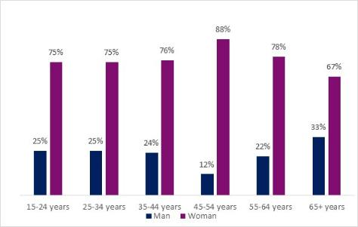

Figure 1: Shows the VGSO gender composition remains relatively consistent throughout the age brackets

**According to the Workplace Gender Equality Agency:**

**What is the Gender Pay Gap?**

The gender pay gap measures the difference between the average earnings of women and men in the workforce, which is shown in figure 3. The gender pay gap is an[internationally established measur](https://www.wgea.gov.au/publications/international-gender-equality-reporting-schemes)[e](https://wgea.gov.au/data/wgea-research/international-gender-equality-reporting-schemes)of women’s position in the economy in comparison to men. The gender pay gap is the result of the social and economic factors that combine to reduce women’s earning capacity over their lifetime.

Closing the gender pay gap goes beyond just ensuring equal pay. It requires cultural change to remove the barriers to the full and equal participation of women in the workforce

**What is not the Gender Pay Gap?**

It is not the difference between two people being paid differently for work of the same or comparable value, which is unlawful. [This is called equal pay.](https://www.wgea.gov.au/pay-equity) Equal Pay is when men and women receive equal pay for work of equal or comparable value. In practical terms, this means that:

* men and women performing the same work are paid the same amount
* men and women performing different work of equal or comparable value are paid the same amount.

**Gender Pay Equity**

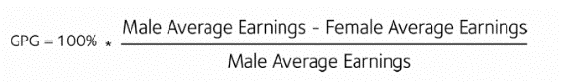

Figure 3: WGEA formula for calculating the Gender Pay Gap

**VGSO Gender Pay Gap**

**VGSO Median**

**Overall pay gap**

**$1,991\***

**VGSO Mean**

**Overall pay gap**

**$588\***

Figure 5: VGSO mean overall pay gap

Figure 4: VGSO median overall pay gap

* One of the main factors that contributes to gender pay gaps is the inability for women to fully participate in the workforce due to care giving responsibilities and working part-time. Our data clearly shows that the pay gap increases for part-time women in comparison to part-time men. New provisions in the Enterprise Agreement should assist in reducing this gap. In addition, we are starting to observe an increasing trend of men taking up parental leave entitlements and returning in a part-time capacity.
* Comparison of data at each classification level shows that was no pay gap at the Executive level. This data is promising as the evidence shows that across Australia there is still a gender pay gap of 22.2% for executives, favouring men.
* It was also positive to see that there is no gender pay gap at the lower grades (VPS 2 and 3)
* One off anomalies or historical factors can influence whether there is a gap.
* In one classification level, there was a much larger women cohort at entry level (i.e. recently promoted/or appointed to that grade) and a much smaller cohort of very experienced men. This skewed the data towards men.
* In another legal classification, there was a small cohort of men towards the top of grade (i.e. on the cusp of promotion) in comparison to women at entry level roles.

For privacy and confidentiality reasons, we are unable to provide any further information in addition to the explanations outline above.

Overall at VGSO, Figure 4 indicates that there is a gender pay gap favouring men. The median base salary indicates there is a 2% gap across the organisation.

The median annualised base salary at the VGSO (as at 30 June 2021) is $96,787 for women and $98,779 for men equating to a pay gap of $1,991 across a financial year.

In comparison, Figure 5 shows that the mean (or average) overall pay gap at VGSO reduces to .5% or equivalent to $588 across a financial year.

As per the definition from the Workplace Gender Equality Agency (WGEA), the gender pay gap calculation is a median figure, defined as the organisational pay gap and measures the difference between the average earnings of women and men in the workforce and is calculated at a point in time. The median represents the middle value in a dataset. The median tends to be a more useful indicator a distribution is skewed and/or has outliers.

The 2% median pay gap calculation is an overall figure and includes VPS Grade 2 to Executive level.

There are a number of factors that need to be taken into account when interpreting these figures:

* The data is taken at a point in time. Future analysis of this data on a regular ongoing basis is likely to show small fluctuations, due to a number of factors, including recruitment activities, promotions, the uptake of part-time work by men and women and VPS secondments.
* In comparison to the overall pay gap in Australia, VGSO’s pay gap is 12.2% lower and 8.7% lower than the Victorian Public Sector, demonstrating that VGSO’s results are significantly better.

|  |  |
| --- | --- |
| **Figure 6: VGSO reports of sexual harassment in the workplace 2021** | |
| **Formal Complaints** | **Informal Data – People Matter Survey** |
| P&C received **0** formal sexual harassment complaints in 2020/21 | **3** People indicated experiencing sexual harassment in the workplace through the survey |

**Workplace Sexual Harassment**

**Sexual Harassment**

In Figure 6, three people who were women reported experiencing sexual harassment in the last 12 months. The behaviour they reported experiencing were

* Intrusive questions about private life or comments on appearance
* Sexually suggestive comments or jokes that made you feel offended (in either a group or one on one situation)

Identified high risks groups include:

* Women aged 15 to 24
* Employees with a self-described gender identity
* LGBTIQ+ identify employees
* Aboriginal and Torres Strait Islanders
* Employees who earn less than $75,000 p.a.

Under the *Equal Opportunity Act 2010* (Vic) employers have a duty to take positive action to eliminate sexual harassment in the workplace. Under the Occupational Health and Safety Act 2004 (Vic), employers must also provide and maintain a work environment that is safe and without risk to the health of their employees. This is inclusive of workplace gendered violence and workplace sexual harassment.

Recent reports by the Victorian Auditor General’s Office found that the Victorian Public Service and Local Government sector workplaces found a consistent gap between formal reports of sexual harassment and experiences of sexual harassment identified through self-reporting surveys.

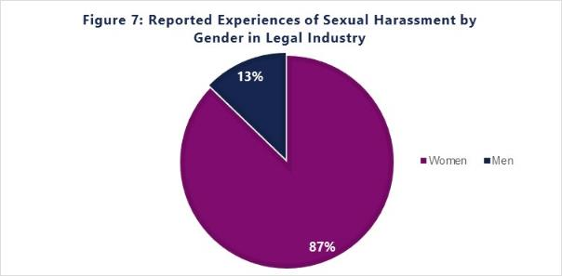

**36%** Legal professionals reported sexual harassment in the legal sector (Australian Human Rights Commission)

**In 2019 the Victorian Legal Services Board produced a report on Sexual Harassment in the Victorian Legal Sector**  where they found that 36% of legal professionals reported sexual harassment.

Of the 36% reported instances of sexual harassment in Figure 6, 87% were from women and 13% from men. While the prevalence of sexual harassment at VGSO are much lower than the legal sector, we would like to see this completely eliminated within our workforce.

**Recruitment and Promotion**

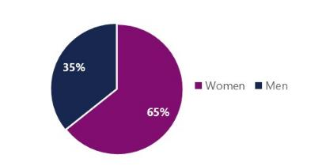

Research in the Australian context identifies a range of ways in which gender bias affects recruitment and promotion processes, including:

* gender coded wording in job advertisements;
* gendered bias in the evaluation of credentials;
* influence of gender norms and stereotypes about certain roles on selection processes; and
* different values placed upon aspirations of leadership/leadership roles.

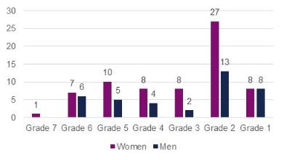

**92% Women - Promotions in the 2020/21 Financial Year.**

This data only included employees who were promoted through the Performance and Development (PDP) process and does not include employees who applied for advertised vacancies.

Recruitment:

Figure 8 indicates that in the 20/21 Financial Year **63%** of people recruited to VGSO were women. More men were recruited at the VPS Grade 6, suggesting a positive shift towards gender balance.

Figure 9 indicates the percentage of men and women recruited to each VPS classification level.

Figure 9: % of gender recruited to the VGSO 20/21 FY by VPS classification level

Figure 8: % of gender recruited to the VGSO 20/21 FY

**Career Development Opportunities**

**Training opportunities**

**76% Women / 24% Men - 2020/21 financial year.**

* Training opportunities were consistent across both genders and comparable to overall gender composition
* Slightly more opportunities for men at VPS 2 level (38%) – due to graduates and recruitment of male paralegals

**Higher Duties**

**75% Women / 25% Men - 2020/21 financial year.**

* Higher duties consistent with VGSO gender composition
* Majority of the opportunities to Act up in higher grades were for employees at higher levels

**Secondment (VPS)**

**50% Women / 50% Men - 2020/21 financial year.**

* Higher duties consistent with VGSO gender composition
* Majority of the opportunities to Act up in higher grades were for employees at higher levels

**Workplace Flexibility**

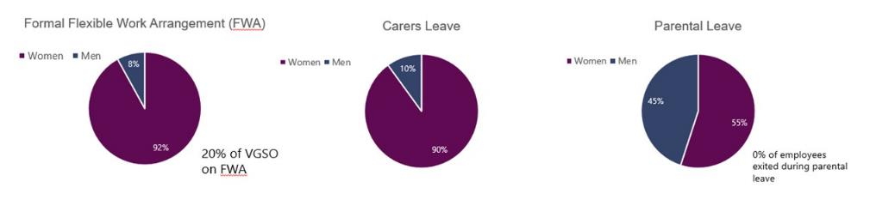

**Figure 12** Shows that 55% women took parental leave in the 20/21 FY.

* Increased uptake of men accessing parental leave – likely due to introduction of secondary care giver leave in EBA
* Only women using unpaid leave for parental leave

As per research collated by the Workplace Gender Equality Agency, the benefits of flexible work are broad reaching, for individuals, organisations and society. Key benefits in the workplace include:

* Improved productivity resulting from increased employee engagement and performance;
* Improved well-being resulting from autonomy to balance professional and personal commitments; and
* Increased gender diversity as a result of flexible work arrangements enabling improved career progression opportunities for women with caring responsibilities.

Figure 10: 92% Women on a Formal Flexible Work Arrangement Figure 11: 90% Women took carers leave in 20/21 FY Figure 12: 55% Women took Parental Leave in 20/21 FY

**People Leaders Flexible Work Arrangements**

* Study leave (2%)
* Purchased leave (3%)
* Part-time (43%)
* Do not use a FWA (51%)

**Figure 11: Carer's Leave -** Currently the majority of employees who are using parental leave are women.

1. [About the Gender Equality Act 2020](https://www.genderequalitycommission.vic.gov.au/about-gender-equality-act-2020) (Commission for Gender Equality in the Public Sector, 2022)
2. [Gender and health](https://www.who.int/health-topics/gender#tab=tab_1) (World Health Organisation)
3. [Gender equality: what is it and why do we need it?](https://www.vic.gov.au/gender-equality-what-it-and-why-do-we-need-it) (Victorian Government, 2021)
4. [Understanding intersectionality](https://www.vic.gov.au/understanding-intersectionality) (Victorian Government, 2021)
5. [Applying intersectionality](https://www.genderequalitycommission.vic.gov.au/applying-intersectionality) (Commission for Gender Equality in the Public Sector, 2022)